SOLARA MULTI-STRATEGY SCANNER

Functional Specification v2.0

Document Control
- Document Title: Solara Multi-Strategy Scanner Specification
- Version: 2.0
- Date: December 2024
- Status: Active Development
- Based On: Current working Solara.mq5 codebase
- Target: Integration with Pullback Trading System (PTS)

1. EXECUTIVE SUMMARY
Solara is a multi-strategy trading scanner for MetaTrader 5 that operates in two modes:
- SCANNING MODE: Screen symbols for trading signals and log to CSV
- TRADING MODE: Automatically execute trades based on signals
Current Status: Solara.mq5 is operational with EMA crossover strategy.
New Integration: Adding Pullback Trading System (PTS) as a second strategy.
Key Features (Current + Planned):
- ✅ EMA 20/50 Crossover Strategy (Existing)
- ✅ Multi-symbol scanning (40+ forex pairs)
- ✅ Multi-timeframe scanning (H1, H4, D1)
- ✅ CSV logging of all signals
- ✅ Daily loss limits
- 🔄 PULLBACK TRADING STRATEGY (New)
- 🔄 Strategy toggle system (On/Off per strategy)
- 🔄 Independent configuration per strategy

2. CURRENT ARCHITECTURE (As Built)

2.1 File Structure (ACTUAL)
Solara/
├── Solara.mq5 (MAIN EA - Working)
├── EMAStrategy.mqh (EMA Crossover Strategy)
├── TradeLogger.mqh (CSV Logging & Trade Execution)
├── ScannerCore.mqh (Utility Functions)
└── SymbolList.mqh (Symbol Definitions)

2.2 Current Component Overview
Component | Status | Purpose
Solara.mq5 | ✅ Working | Main EA with timer-based scanning
EMAStrategy.mqh | ✅ Working | EMA 20/50 crossover logic
TradeLogger.mqh | ✅ Working | CSV logging & trade execution
ScannerCore.mqh | ✅ Working | Symbol validation & new bar detection
SymbolList.mqh | ✅ Working | List of symbols to scan

3. TARGET ARCHITECTURE (After PTS Integration)

3.1 Revised File Structure
Solara/
├── Solara.mq5 (MAIN EA - Enhanced)
├── StrategyBase.mqh (NEW - Abstract base class)
├── StrategyManager.mqh (NEW - Strategy orchestration)
├── Configuration.mqh (NEW - Central config)
├── TradeLogger.mqh (Enhanced for multi-strategy)
├── ScannerCore.mqh (Enhanced)
├── SymbolList.mqh (No change)
└── Strategies/ (NEW - Strategy implementations)
├── EMAStrategy.mqh (Refactored to extend StrategyBase)
└── PTSStrategy.mqh (NEW - Pullback Trading Strategy)

3.2 Component Relationships
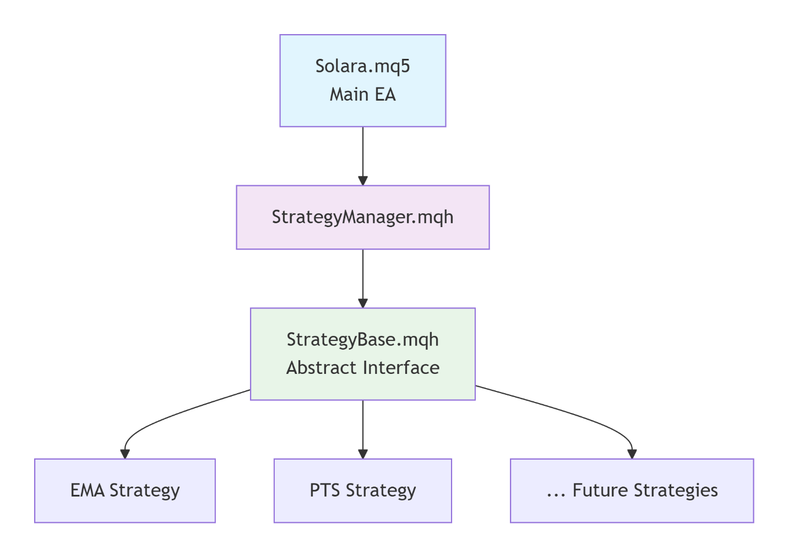

4. STRATEGY TOGGLE SYSTEM (NEW FEATURE)

4.1 User Interface Design
// In Solara.mq5 Input Parameters
input group "=== STRATEGY SELECTION ==="
input bool Enable_EMA_Strategy = true; // [✔] Enable EMA Crossover
input bool Enable_PTS_Strategy = false; // [ ] Enable Pullback Trading

input group "=== EMA STRATEGY SETTINGS ==="
input int EMA_FastPeriod = 20;
input int EMA_SlowPeriod = 50;
// ... existing EMA inputs

input group "=== PTS STRATEGY SETTINGS ==="
input double PTS_LotSize = 0.01;
input int PTS_MaxPositions = 10;
input string PTS_CSVFile = "QualifiedPairs.csv";
// ... PTS-specific inputs

4.2 Toggle Behavior
State | Description
EMA ON, PTS OFF | Current behavior (backward compatible)
EMA OFF, PTS ON | Test PTS strategy in isolation
BOTH ON | Both strategies active (max positions apply)
BOTH OFF | Scanner runs but no trades (monitoring only)
4.3 Magic Number Allocation
Strategy | Magic Number | Comment Format
EMA | 12345 | "EMA_Crossover"
PTS | 202412 | "PTS: H4 Pullback [LONG/SHORT]"

5. EMA STRATEGY (CURRENT - To Be Refactored)

5.1 Current Logic (As Coded)
// Entry Conditions:
1. Previous bar: EMA20 > EMA50 (crossover)
2. Current bar: Close OR body midpoint > EMA20

// Exit Conditions:
1. Current close < EMA20

// Timeframes: H1, H4, D1 (user selectable)
// Scanning: Every ScanIntervalSeconds

5.2 Refactoring Requirements
- Extend StrategyBase class
- Maintain backward compatibility
- Add toggle support
- Separate configuration from logic

6. PTS STRATEGY (NEW - Based on PTS Spec)

6.1 Core Logic
// TWO-LAYER SYSTEM:
// LAYER 1: Daily Filter (00:05 GMT)
1. Check D1 EMA50 trend (price above/below)
2. Check volatility (ATR > 50% of average)
3. Output: QualifiedPairs.csv

// LAYER 2: 4-Hour Entry (6 times daily)
1. Read qualified pairs from CSV
2. Check Bollinger Band touch
3. Check reversal candle pattern
4. Enter with 1:2 risk-reward (2×ATR SL, 4×ATR TP)
6.2 Schedule
Time (GMT) | Action
00:05 | Daily Filter + Immediate H4 Scan
04:00 | H4 Scan
08:00 | H4 Scan
12:00 | H4 Scan
16:00 | H4 Scan
20:00 | H4 Scan

6.3 Entry Conditions
For LONG (Buy dips in uptrend):
- H4 price touches lower Bollinger Band
- Bullish reversal candle (Engulfing/Hammer/Strong Close)
For SHORT (Sell rallies in downtrend):
- H4 price touches upper Bollinger Band
- Bearish reversal candle (Engulfing/Shooting Star/Strong Close)

6.4 Risk Management
- Stop Loss: Entry ± 2×ATR
- Take Profit: Entry ± 4×ATR (1:2 ratio)
- Max Positions: 10 concurrent
- One position per pair

7. CONFIGURATION SYSTEM

7.1 Input Parameter Groups
// Group 1: Global Settings (Apply to all strategies)
input group "=== GLOBAL SETTINGS ==="
input bool EnableTrading = false; // Master trading toggle
input int ScanIntervalSeconds = 60; // Base scan frequency
input double GlobalDailyLossLimit = 500.0; // Total daily loss limit

// Group 2: EMA Strategy
input group "=== EMA STRATEGY ==="
input bool Enable_EMA_Strategy = true;
// ... EMA-specific inputs

// Group 3: PTS Strategy
input group "=== PTS STRATEGY ==="
input bool Enable_PTS_Strategy = false;
// ... PTS-specific inputs
7.2 CSV Files Management
File | Purpose | Strategy
ScannerSignals.csv | All trade signals | Both
QualifiedPairs.csv | Daily qualified pairs | PTS only
TradeLog.csv | Executed trades | Both

8. RISK MANAGEMENT SYSTEM

8.1 Multi-Level Risk Controls

8.2 Position Counting
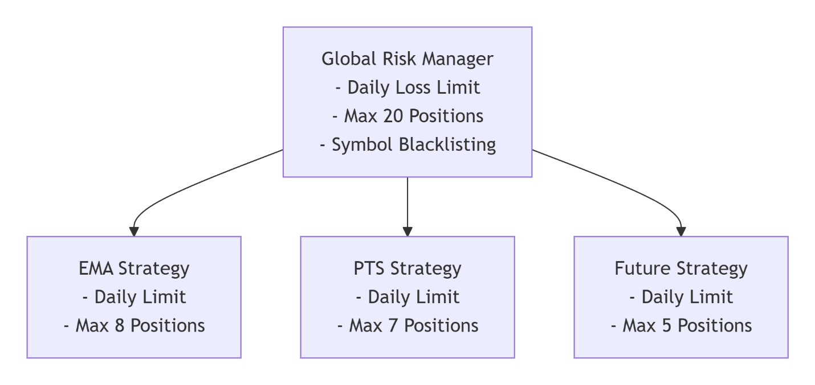
// Per Strategy: Count by magic number
int EMA_Positions = CountPositionsByMagic(12345);
int PTS_Positions = CountPositionsByMagic(202412);

// Global: Sum of all strategies
int Total_Positions = EMA_Positions + PTS_Positions;

8.3 Loss Tracking
// Separate tracking per strategy
double EMA_DailyLoss = 0.0;
double PTS_DailyLoss = 0.0;

// Global tracking
double Global_DailyLoss = EMA_DailyLoss + PTS_DailyLoss;

9. EXECUTION FLOW

9.1 Initialization Sequence

OnInit()
↓
Load SymbolList.mqh
↓
Initialize TradeLogger
↓
Initialize StrategyManager
↓
IF Enable_EMA_Strategy → Load EMAStrategy
↓
IF Enable_PTS_Strategy → Load PTSStrategy
↓
Set Timer (ScanIntervalSeconds)
↓
Start Strategies
9.2 Timer Execution Flow

OnTimer()
↓
StrategyManager.OnTimer()
↓
├── IF 00:05 GMT → PTS.DailyFilter()
│ └── Create QualifiedPairs.csv
│
├── IF H4 Scan Time → PTS.H4Scan()
│ └── Check qualified pairs for entries
│
├── EMA Strategy Scan
│ └── Check all symbols on selected timeframes
│
└── Update Statistics & Chart Comment

9.3 Trade Execution Flow
Strategy Generates Signal
↓
Check: Is strategy enabled? (Toggle)
↓
Check: Daily loss limit not exceeded
↓
Check: Max positions not reached
↓
Check: No existing position on symbol
↓
Execute Trade via TradeLogger
↓
Log to CSV & Update Statistics

10. ERROR HANDLING

10.1 Error Categories
Category | Examples | Response
Configuration | Invalid period, lot size | Log error, disable strategy
Market Data | Symbol not available | Skip symbol, log warning
File I/O | Cannot open CSV | Retry, log error
Trade Execution | Order rejected | Log error, no retry

10.2 Recovery Procedures
- CSV File Missing: Recreate file on next daily filter
- Indicator Failure: Release handles, recreate
- Broker Disconnect: Pause trading until reconnected
- Memory Issue: Clear cache, restart timer

11. PERFORMANCE MONITORING

11.1 Real-time Statistics
// Per Strategy Metrics
struct StrategyMetrics {
string name;
int signals_today;
int trades_today;
int wins_today;
int losses_today;
double pnl_today;
double pnl_total;
};

// Global Metrics
int TotalScans = 0;
int TotalSignals = 0;
int TotalTrades = 0;
datetime LastScanTime = 0;
11.2 Chart Comment Display

Solara Scanner v2.0
====================
Mode: TRADING | SCANNING: ON
Strategies: EMA[ON] PTS[OFF]
Symbols: 40 | Scans: 1245
Signals: 45 | Trades: 12
Daily P&L: EMA: +$45 | PTS: $0
Total P&L: +$320
Last Scan: 14:32:05
Next Scan: 14:33:05

12. TESTING REQUIREMENTS

12.1 Unit Tests
- EMA Strategy: Verify crossover logic, exit conditions
- PTS Strategy: Verify daily filter, H4 entry logic
- Toggle System: Verify enable/disable functionality
- Risk Management: Verify position counting, loss limits

12.2 Integration Tests
- Both Strategies ON: Verify no interference
- CSV Operations: Verify file creation/reading
- Timer Accuracy: Verify 00:05 GMT execution
- Trade Execution: Verify correct magic numbers

12.3 Backtesting Requirements
Strategy | Minimum Period | Pairs | Win Rate Target
EMA | 2 years | All in SymbolList | >35%
PTS | 3 years | All in SymbolList | >35%
Combined | 2 years | All in SymbolList | >35%

13. MIGRATION PATH

13.1 Phase 1: Preparation (Week 1)
- ✅ Analyze current code (DONE)
- ✅ Update functional specs (THIS DOCUMENT)
- Create StrategyBase.mqh
- Create StrategyManager.mqh
- Create Configuration.mqh

13.2 Phase 2: Refactoring (Week 2)
- Refactor EMAStrategy to extend StrategyBase
- Update TradeLogger for multi-strategy support
- Add toggle system to Solara.mq5
- Test EMA strategy still works

13.3 Phase 3: PTS Development (Week 3)
- Create PTSStrategy.mqh
- Implement daily filter (00:05 GMT)
- Implement H4 scanning schedule
- Implement 1:2 risk-reward exits

13.4 Phase 4: Integration (Week 4)
- Integrate PTS into StrategyManager
- Test both strategies together
- Verify risk management across strategies
- Demo testing (2 weeks minimum)

13.5 Phase 5: Optimization (Future)
- Add advanced risk management
- Add performance reporting
- Add additional strategies

14. SUCCESS CRITERIA

14.1 Functional Requirements
- EMA strategy works exactly as before
- Users can toggle strategies on/off
- PTS strategy executes per specification
- Both strategies can run simultaneously
- Risk limits are enforced per strategy
- CSV logging works for both strategies

14.2 Performance Requirements
- No degradation in scanning speed
- Memory usage within limits
- Accurate 00:05 GMT execution for PTS
- Trade execution within 5 seconds

14.3 Quality Requirements
- No crashes in 30-day demo test
- Backtest shows positive expectancy
- All errors properly logged
- Configuration persists across restarts

15. GLOSSARY
Term | Definition
EMA Strategy | Existing EMA 20/50 crossover system
PTS Strategy | Pullback Trading System (new)
Qualified Pairs | Pairs that pass daily trend filter (PTS)
Magic Number | Unique ID for strategy's trades
Toggle System | On/Off switch for each strategy
Daily Filter | PTS process that runs at 00:05 GMT
H4 Scan | PTS entry check that runs 6x daily

16. APPENDICES
Appendix A: Current Code Summary
- Solara.mq5: 500+ lines, timer-based, working
- EMAStrategy.mqh: 300+ lines, crossover logic
- TradeLogger.mqh: 400+ lines, CSV and execution
- ScannerCore.mqh: 100+ lines, utilities
- SymbolList.mqh: 50+ lines, 40+ symbols
Appendix B: PTS Specification Summary
- Strategy: Pullback trading in trends
- Timeframes: D1 for trend, H4 for entry
- Entry: BB touch + reversal candle
- Exit: Fixed 1:2 risk-reward ratio
- Schedule: Daily filter at 00:05, H4 scans every 4 hours

